FTP server is used to exchange files between computers over network . This guide helps you to setup ftp server on centos 7 . This guide contains configuration steps for both FTP and SFTP as well as user creation . Here i’ve used VSFTP package which is secure and less vulnerable .
1. FTP Server
2. SFTP Server
3. User creation

Setup FTP server on centos 7
Step 1 » Update your repository and install VSFTPD package .
[root@krizna ~]# yum check-update
[root@krizna ~]# yum -y install vsftpd
Step 2 » After installation you can find /etc/vsftpd/vsftpd.conf file which is the main configuration file for VSFTP.
Take a backup copy before making changes .
[root@krizna ~]# mv /etc/vsftpd/vsftpd.conf /etc/vsftpd/vsftpd.conf.org
Now open the file and make changes as below
[root@krizna ~]# nano /etc/vsftpd/vsftpd.conf
Find this line anonymous_enable=YES ( Line no : 12 ) and change value to NO to disable anonymous FTP access.
anonymous_enable=NO
Uncomment the below line ( Line no : 100 ) to restrict users to their home directory.
chroot_local_user=YES
and add the below lines at the end of the file to enable passive mode and allow chroot writable.
allow_writeable_chroot=YES
pasv_enable=Yes
pasv_min_port=40000
pasv_max_port=40100
Step 3 » Now restart vsftpd service and make it start automatically after reboot.
[root@krizna ~]# systemctl restart vsftpd.service
[root@krizna ~]# systemctl enable vsftpd.service
Step 4 » Add FTP service in firewall to allow ftp ports .
[root@krizna ~]# firewall-cmd --permanent --add-service=ftp
[root@krizna ~]# firewall-cmd --reload
Step 5 » Setup SEinux to allow ftp access to the users home directories .
[root@krizna ~]# setsebool -P ftp_home_dir on
Step 6 » Now create an User for ftp access. Here /sbin/nologin shell is used to prevent shell access to the server .
[root@krizna ~]# useradd -m personel_ftp -s /sbin/nologin
[root@krizna ~]# passwd personel_ftp

mkdir /home/ftp_user/www_dev
mount --bind /var/www/dev/ /home/ftp_user/www_dev
After this the ftp user will be able to see the needed files in his home directory and use them in his ftp client as if they were local files.
If you need to make this configuration permanent you can either add the mount command in some startup script or you can just include a line in /etc/fstab:
/var/www/dev /home/ftp_user/www_dev none bind 0 0

Now user dave can able to login ftp on port 21 .
You can filezilla or winscp client for accessing files.
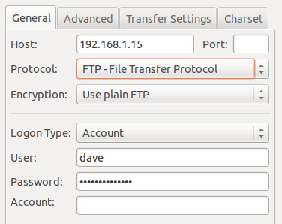

SFTP server
SFTP ( Secure File Transfer Protocol ) is used to encrypt connections between clients and the FTP server. It is highly recommended to use SFTP because data is transferred over encrypted connection using SSH-tunnel on port 22 .
Basically we need openssh-server package to enable SFTP .
Install openssh-server package, if its not already installed.
[root@krizna ~]# yum -y install openssh-server
Step 7 » Create a separate group for FTP access.
[root@krizna ~]# groupadd ftpaccess
Step 8 » Now open /etc/ssh/sshd_config file and make changes as below.
Find and comment the below line ( Line no : 147 ).
#Subsystem sftp /usr/libexec/openssh/sftp-server
and add these lines below.
Subsystem sftp internal-sftp
Match group ftpaccess
ChrootDirectory %h
X11Forwarding no
AllowTcpForwarding no
ForceCommand internal-sftp
Step 9 » Now restart sshd service.
[root@krizna ~]# systemctl restart sshd
Now your SFTP server is configured and ready .

User creation
Step 10 » Create user jack with /sbin/nologin shell and ftpaccess group
[root@krizna ~]# useradd -m jack -s /sbin/nologin -g ftpaccess
[root@krizna ~]# passwd jack
Now assign root ownership for the home directory for chroot access and modify permission.
[root@krizna ~]# chown root /home/jack
[root@krizna ~]# chmod 750 /home/jack
Create a directory www inside home directory for writing and modify ownership .
[root@krizna ~]# mkdir /home/jack/www
[root@krizna ~]# chown jack:ftpaccess /home/jack/www
Now jack can use both ftp and sftp services . He can upload files in www directory .
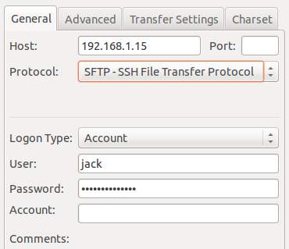
If you are going to use FTP and SFTP together in the same server, you should follow above steps while creating users . For existing users add them to ftpaccess and make below changes.
[root@krizna ~]# usermod dave -g ftpaccess
[root@krizna ~]# chown root /home/dave
[root@krizna ~]# chmod 750 /home/dave
[root@krizna ~]# mkdir /home/dave/www
[root@krizna ~]# chown dave:ftpaccess /home/dave/www

